Below are the steps:

Clone this Github repository <https://github.com/Vikas098766/Microservices.git>

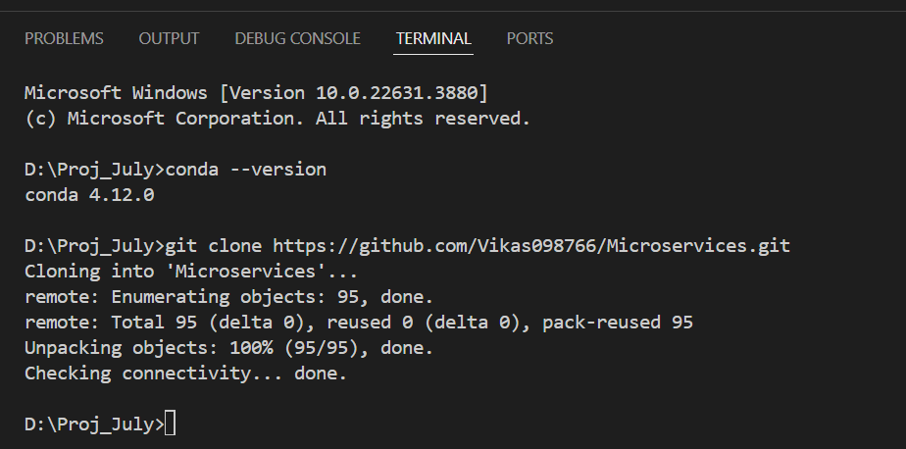

Create a Virtual Environment

Create requirements.txt file

Create app.py file and write the code and run the code

